Capstone Project On

“Beyond Melody: A Text Mining Approach on Song Success on Spotify”

Submitted in the partial fulfilment of the requirements for the award of the degree of

MASTER OF BUSINESS ADMINISTRATION (BUSINESS ANALYTICS)

By
BODDAPATI KANCHANA
(24MBMB02)
MBA 2024-26

Under the esteemed guidance of
SREE LAKSHMI MAM
SCHOOL OF MANAGEMENT STUDIES
UNIVERSITY OF HYDERABAD

SCHOOL OF MANAGEMENT STUDIES, UNIVERSITY OF HYDERABAD, Prof. CR Rao Road
Gachebowli, Hyderabad, Telangana, 500046

DECLARATION

I, Boddapati Kanchana (Roll No: 24MBMB02), hereby declare that the Capstone Project entitled “Beyond Melody: A Text Mining Approach on Song Success on Spotify” submitted to School of Management Studies, University of Hyderabad in partial fulfillment of the requirements for the award of the degree of Master of Business Administration in Business Analytics, is a record of original work carried out by me during my course called Text, Social Media and Web Analytics at School of Management Studies, University of Hyderabad.
I further declare that this report is the result of my own efforts and has not been submitted to any other University/Institute for the award of any degree, diploma, or fellowship. All sources of information used have been duly acknowledged in the references.

Place: School of Management Studies
University of Hyderabad
Date:

Signature of the Student
Boddapati Kanchana
Roll No: 24MBMB02
School of Management Studies
University of Hyderabad
Table of Contents

Executive Summary 4
CHAPTER 1: INTRODUCTION 5
CHAPTER 2: LITERATURE REVIEW 9
CHAPTER 3: METHODOLOGY 13
CHAPTER 4: DATA ANALYSIS 22
CHAPTER 5 – CONCLUSION AND FUTURE SCOPE 30

Executive Summary

The project titled “Beyond Melody: A Text Mining Approach on Song Success on Spotify” explores how linguistic, emotional, and acoustic factors contribute to a song’s success on Spotify.
In an era of digital streaming, data-driven music analysis provides powerful tools to understand listener preferences and global music trends.
This project combines text mining, machine learning, and statistical modeling to uncover patterns that influence song popularity across different languages and genres.
Data for the study was obtained from publicly available Spotify and lyrics datasets, merged using song titles and artist names.
After cleaning and preprocessing, five analytical use cases were developed to address distinct aspects of musical performance:
- Theme Classification – Identified dominant lyrical themes using a keyword-based approach, revealing that love and motivation are the most prevalent across popular songs.
- Genre Classification – Predicted song genres using audio attributes and a Random Forest Classifier, confirming that energy, rhythm, and valence effectively differentiate musical styles.
- Cross-Cultural Song Success – Analysed average popularity by language, showing that Spanish songs outperformed English ones, reflecting the global rise of Latin and multilingual music.
- Audio Feature Impact on Popularity – Applied Random Forest Regression to determine that loudness, energy, and liveness most strongly influence Spotify popularity.
- Sentiment Analysis – Measured lyrical polarity using TextBlob and found that negative or emotionally intense lyrics resonated most with listeners, suggesting a connection between emotional authenticity and engagement.
Visualizations were produced using Matplotlib and Seaborn, while Scikit-learn and TextBlob powered the analytical modeling.
The findings highlight that musical popularity is multidimensional, shaped by emotional tone, production quality, and cultural diversity.
The study demonstrates how data analytics can bridge art and technology, providing actionable insights for artists, producers, and streaming platforms to better understand global audience behaviour.

CHAPTER 1: INTRODUCTION

1.1 Background of the Study
In the current age of digital music, streaming services like Spotify have changed how we find, listen to, and judge songs. With millions of tracks accessible globally, figuring out what makes a song hit has turned into both a challenge and a chance.
The success of a song is shaped by many factors, including the depth of the lyrics, emotional resonance, genre, sound quality, and even the diversity of culture and language. Since listeners come from various backgrounds and speak different languages, using data analytics to examine these complex factors can reveal important insights about what audiences like and the trends in the market.
Thanks to advancements in Machine Learning (ML) and Natural Language Processing (NLP), we can now analyse song lyrics, feelings, and sound patterns in a systematic way to predict and understand what makes music successful. This research uses both text and numerical data from Spotify and lyrics databases to investigate crucial questions about how themes, genres, emotions, and cultural elements affect a song's popularity.

1.2 Need for the Study
The worldwide music industry produces a massive amount of data every day — including lyrics, metadata, audio characteristics, and user interactions. Yet, the main difficulty is turning this data into useful insights that can assist:
- Artists in grasping what connects with listeners,
- Music producers in enhancing their creative choices, and
- Streaming services in improving their recommendation algorithms.
This project aims to fill that void by combining data analytics, natural language processing, and predictive modeling to reveal what contributes to a song's success across various genres, emotions, and cultures. The research focuses not just on predictive accuracy but also on interpretability — figuring out why some songs do better than others.

1.3 Problem Statement
Even though there is a lot of song data out there, not much research has been done that looks at the combination of lyrics, audio features, and language variety to assess how successful a song is. Some songs become hits because they have catchy rhythms, while others resonate due to their emotional or cultural significance.
As a result, this study intends to fill this gap in analysis by creating data-driven models that will investigate and forecast song success from various angles — including themes, music, emotions, and culture.

1.4 Objectives of the Study
The primary goal of this project is to use text mining and data analytics methods to examine the elements that lead to a song's success on Spotify.
In particular, the research focuses on five unique yet related use cases:
Use Case 1: Theme Classification
To identify the dominant theme (e.g., love, motivation, heartbreak, party) of a song using its lyrical patterns through TF-IDF vectorization and machine learning classification.
Use Case 2: Genre Classification
To predict the genre of a song (e.g., pop, rock, hip-hop, classical) based on its lyrical content, thereby understanding how language style and vocabulary differ across musical genres.
Use Case 3: Cross-Cultural and Multilingual Song Success
To analyse how language impacts a song’s popularity and reach across different cultures by comparing average popularity scores and demand across languages.
Use Case 4: Audio Feature Impact on Popularity
To identify which audio features (such as danceability, energy, tempo, and valence) have the greatest influence on Spotify popularity, using correlation and regression-based approaches.

Use Case 5: Sentiment and Emotion Analysis of Lyrics
To examine how the emotional tone (positive, negative, or neutral) of lyrics affects song popularity and listener engagement, using sentiment analysis tools like TextBlob or VADER.

1.5 Scope of the Study
The study focuses exclusively on songs available in the Spotify database that have corresponding lyrical data.
- It covers textual features (lyrics), numerical features (audio attributes), and categorical features (language and genre).
- The research is limited to analysing the correlation and prediction of success indicators (popularity scores) and does not include real-time streaming behaviour.
- The study uses Python, pandas, scikit-learn, and NLP libraries for preprocessing, modeling, and visualization.
By combining machine learning and sentiment analysis, the project aims to provide a holistic view of song success across emotional, musical, and cultural dimensions.

1.6 Significance of the Study
The findings of this project hold value for multiple stakeholders:
- Artists and songwriters can understand which lyrical and emotional patterns connect most with audiences.
- Music producers can identify the audio attributes associated with popular songs.
- Streaming platforms can improve recommendation algorithms by incorporating theme and emotion detection.
- Academia and researchers can use this as a case study for applying text mining in creative industries.
Overall, the project demonstrates how data-driven creativity can be combined with machine learning to uncover patterns that define musical success in the digital age.

1.7 Methodological Overview
The study follows a structured analytical approach involving:
- Data Collection – Spotify and lyrics datasets were merged using song title as a key.
- Preprocessing – Cleaning lyrics, handling null values, and generating new columns (lyrics_clean, sentiment scores).
- Feature Engineering – Using TF-IDF for text, and standardizing audio features for regression.
- Model Development – Applying Logistic Regression, Random Forest, and sentiment analysis models.
- Visualization – Using Seaborn and Matplotlib for interpretive graphs.
- Evaluation – Using accuracy, precision, recall, and F1-scores for classification, and correlation metrics for popularity analysis.

1.8 Expected Outcomes
- Accurate classification of songs by theme and genre using machine learning.
- Clear identification of audio and textual features influencing song popularity.
- Visual insights into cross-cultural trends in global music.
- Understanding of how emotional sentiment in lyrics contributes to song success.

CHAPTER 2: LITERATURE REVIEW

2.1 Introduction
This chapter reviews existing studies, theories, and analytical frameworks related to the prediction of song success using data analytics, machine learning, and text mining techniques. The review focuses on three primary aspects — (1) the influence of lyrics and emotions, (2) the impact of musical and audio features, and (3) cross-cultural and linguistic diversity in global music. It also highlights research gaps that this project aims to address.

2.2 Music Analytics and the Digital Era
The rise of digital streaming platforms such as Spotify, Apple Music, and YouTube Music has transformed the music industry into a data-driven ecosystem.
According to Datta et al. (2018), the availability of streaming data allows researchers to quantify listener preferences and predict success metrics such as popularity, virality, and user engagement.
Similarly, Ferwerda & Tkalcic (2019) emphasize that music analytics integrates multiple data modalities — including textual, auditory, and behavioural features — to provide holistic insights into user taste and content performance.
However, most studies have focused heavily on audio and acoustic data, leaving lyrical and emotional analysis comparatively underexplored.

2.3 Role of Lyrics and Themes in Music Success
Lyrics are often the emotional and expressive core of a song. They influence the listener’s connection, recall, and emotional resonance.
Mayer et al. (2019) demonstrated that lyrical content could be used to identify thematic structures like love, heartbreak, or celebration, which strongly correlate with audience sentiment and streaming patterns.
Hu et al. (2009) developed a corpus of labelled songs to analyse mood and theme classification using word frequency and sentiment metrics, proving that text-based features can successfully predict emotional tone.
For instance, songs with repetitive, relatable, and emotionally charged words were found to perform better across multiple genres. This supports the first use case of this project — Theme Classification — which aims to identify recurring lyrical patterns that define successful songs.

2.4 Genre Classification Using Textual and Audio Features
The genre of a song encapsulates its rhythmic structure, instrumentation, and stylistic elements.
Early works such as Tzanetakis & Cook (2002) used spectral and rhythmic audio features to automatically classify genres, achieving around 61% accuracy. Later, Li & Ogihara (2006) combined lyrics and audio data to improve genre prediction performance, demonstrating that linguistic features add a contextual layer that purely acoustic models often miss.
More recent approaches (e.g., Choi et al., 2017) employed deep learning models using both waveform and textual embeddings, confirming that genre classification benefits from a multimodal approach.
This literature supports the second use case — Genre Classification — which uses lyrical data and machine learning to uncover the linguistic nuances of different music genres.

2.5 Cross-Cultural and Multilingual Trends in Global Music
In the age of global streaming, music transcends cultural and linguistic boundaries.
Studies such as Park et al. (2020) on K-pop and Ordanini & Nunes (2016) on global hit songs highlight how cross-cultural collaborations and multilingual lyrics have expanded audience reach.
They found that English remains dominant on streaming platforms, but non-English songs (e.g., Korean, Spanish, and Hindi) increasingly achieve global success due to social media exposure and cultural fusion.
Pachet & Roy (2014) also analysed language patterns and found that multilingual tracks tend to receive higher engagement in culturally diverse markets.
This forms the basis for the third use case — Cross-Cultural and Multilingual Song Success, where the language and popularity of songs are examined to uncover patterns of cultural influence.

2.6 Audio Features and Popularity Prediction
Spotify provides a set of engineered audio features such as danceability, energy, loudness, valence, and tempo, which describe the acoustic qualities of songs.
Herremans et al. (2014) analysed how these audio characteristics correlate with hit song potential, showing that energetic and rhythmically consistent tracks are often more successful.
Dhanaraj & Logan (2005) found that “danceability” and “valence” were strong predictors of popularity in pop and EDM genres.
Recent research by Schedl et al. (2021) used regression and clustering to rank features by their influence on success metrics, highlighting that danceability and valence consistently rank among the top predictors.
This directly supports the fourth use case — Audio Feature Impact on Popularity, where correlation and regression models are used to understand how musical elements shape audience appeal.

2.7 Sentiment and Emotion Analysis in Music
Sentiment analysis has emerged as a valuable tool to assess the emotional tone of lyrics.
Dodds et al. (2015) analysed 200 years of English song lyrics and found a measurable decline in overall happiness, showing that cultural mood shifts influence lyrical expression.
Yang & Lee (2004) developed mood classification systems based on emotional word usage, achieving over 70% accuracy.
Similarly, Panda et al. (2020) demonstrated that polarity and subjectivity scores can be correlated with listener engagement and popularity metrics.
This evidence validates the fifth use case — Sentiment and Emotion Analysis, which uses polarity and subjectivity scores to reveal how positive or negative emotions in lyrics affect popularity.

2.8 Research Gaps Identified
From the literature reviewed, several research gaps are evident:
- Limited integration of lyrical, audio, and cultural attributes within a single analytical framework.
- Underrepresentation of non-English songs in data-driven studies.
- Lack of interpretable models connecting sentiment, theme, and success metrics.
- Minimal emphasis on visual interpretation and comparative analysis across dimensions such as genre and language.
This project addresses these gaps by combining text mining, machine learning, and cultural analytics in a unified model to interpret song success from multiple perspectives.

2.9 Summary
The reviewed studies highlight that song success is a multidimensional phenomenon influenced by lyrics, emotions, musical attributes, and cultural diversity.
While earlier works focused primarily on audio analysis, recent advancements emphasize the potential of NLP and sentiment-based models in uncovering deeper insights.
By integrating these perspectives, this project contributes a comprehensive and interpretable framework to evaluate what makes songs popular across themes, genres, and cultures using modern data analytics techniques.

CHAPTER 3: METHODOLOGY

3.1 Introduction
This chapter explains the systematic process adopted to analyses lyrical, musical, and cultural factors influencing song success on Spotify. The study uses a quantitative, analytical, and exploratory approach combining data preprocessing, feature engineering, machine learning, and visualization.
The methodology is designed to address the five research use cases identified earlier:
- Theme Classification
- Genre Classification
- Cross-Cultural and Multilingual Song Success
- Audio Feature Impact on Popularity
- Sentiment and Emotion Analysis of Lyrics
Each use case follows a structured workflow — from data acquisition to result interpretation — ensuring analytical consistency across text-based and numerical dimensions of the dataset.

3.2 Data Collection
The project uses two primary datasets:
- Spotify Song Dataset – contains metadata and quantitative song features including track name, artist name, genre, popularity, and audio features such as danceability, energy, loudness, valence, and tempo.
- Lyrics Dataset – provides the full textual lyrics corresponding to songs in the Spotify dataset.
These datasets were merged using the song title (track name) as the key attribute. The combined dataset initially contained over 4,000 records after removing duplicates and irrelevant entries. This integration allowed the inclusion of both textual data (lyrics) and numerical data (audio features) essential for multi-dimensional analysis.
3.3 Data Preprocessing
3.3.1 Data Cleaning
- Removed rows containing null values in key columns such as lyrics, genres, and language.
- Standardized text columns (converted to lowercase, removed punctuation, digits, emojis, and special symbols).
- Created a new processed column lyrics_clean for cleaned lyrical content.
- Removed duplicate song entries and harmonized naming inconsistencies.
- Filtered songs with missing or undefined language tags.
3.3.2 Handling Numerical Attributes
- Normalized numerical audio features (danceability, loudness, tempo, etc.) using Min-Max scaling to maintain consistency in regression and correlation analysis.
- Checked for outliers in popularity and tempo distributions.
3.3.3 Data Integration
The datasets were successfully joined using partial text matching on song titles to ensure maximum overlap. After merging, the dataset was stored for further text mining and modeling.

3.4 Feature Engineering
3.4.1 Text Feature Extraction
To convert lyrics into a numerical format for model training, the TF-IDF (Term Frequency–Inverse Document Frequency) vectorization technique was applied.
This technique assigns weight to words based on their frequency in a song and rarity across all songs, emphasizing unique and meaningful terms.
3.4.2 Sentiment Feature Creation
For the fifth use case, sentiment polarity and subjectivity were extracted using the TextBlob library:

- Polarity measures positivity or negativity (range: -1 to +1).
- Subjectivity captures how opinionated or objective the lyrics are (range: 0 to 1).
These metrics were stored as new columns sentiment_score and subjectivity_score.
3.4.3 Audio Features
From the Spotify dataset, the following numeric attributes were retained for quantitative modelling: danceability, energy, loudness, valence, acousticness, instrumentalness, liveness, speechiness. and tempo. These serve as predictors for popularity analysis and feature importance evaluation.

3.5 Model Building and Analytical Approach
Use Case 1: Theme Classification
Objective:
Identify the dominant lyrical theme (Love, Sadness, Motivation, Party, Nature, or Other) from each song’s cleaned lyrics.
Process:
- Input: lyrics_clean column containing pre-processed text.
- Technique: A keyword-based rule approach.
  - A dictionary of theme keywords (themes dictionary) was defined.
  - Each lyric was scanned for occurrences of those keywords.
  - The theme with the highest keyword count was assigned to the song.
  - If no theme words were found, the label “other” was used.
- Visualization: Frequency of each detected theme plotted as a bar chart.
- No machine-learning model (e.g., TF-IDF + Logistic Regression) was used; classification relied purely on lexical matching.

Expected Outcome:
A fast, interpretable mapping of songs into coarse emotional or conceptual categories, showing which lyrical themes dominate across the dataset (e.g., Love-related songs being most frequent).
Use Case 2: Genre Classification
Objective:
Predict a song’s genre using its audio characteristics (such as energy, danceability, and valence) to understand how musical features distinguish different genres.
Process:
- Input features: danceability, energy, loudness, speechiness, acousticness, instrumentalness, liveness, valence, and tempo.
- Target column: genres
- Technique:
  - Filtered out rare genres (fewer than 5 songs).
  - Encoded genre labels numerically with LabelEncoder.
  - Split data into training (80 %) and testing (20 %) sets using stratified sampling.
  - Trained a Random Forest Classifier (n_estimators = 200, max_depth = 15) with class-weight balancing to handle any residual imbalance.
- Evaluation metrics: Classification Report (Precision, Recall, F1 Score) and Confusion Matrix.
- Visualization: Heatmap of the confusion matrix for the 10 most frequent genres.
Expected Outcome:
The model identifies genre-defining patterns in audio attributes, showing, for example, that high-energy, high-danceability tracks cluster under Pop and EDM while low-tempo, high-acousticness tracks cluster under Folk or Acoustic genres. The resulting metrics and plots reveal how well musical features predict genre boundaries and where overlaps occur between similar styles.

Use Case 3: Cross-Cultural and Multilingual Song Success
Objective:
Evaluate how a song’s language influences its popularity and identify patterns of cross-cultural success among multilingual tracks.
Process:
- Input variables:
  - language — represents the linguistic category of each song.
  - track_popularity — Spotify’s popularity score.
- Methodology:
  - Used grouping and aggregation with pandas.groupby() to calculate average popularity for each language.
  - Filtered languages that had fewer than 10 songs to avoid statistical bias.
  - Ranked languages by average popularity to identify those with strong global presence.
- Metrics computed:
  - Average popularity per language → measures listener engagement and success.
  - Song count per language → indicates content supply and demand.
- Visualization:
  - Bar chart displaying average song popularity by language using Seaborn.
Expected Outcome:
Identification of which languages dominate Spotify charts (e.g., English, Spanish, Korean) and which emerging languages show rising cross-cultural appeal.
The results highlight how multilingual tracks transcend regional boundaries, providing evidence of global audience diversity and linguistic inclusivity in music consumption.

Use Case 4: Audio Feature Impact on Popularity
Objective:
Determine which audio attributes (e.g., rhythm, energy, and mood indicators) most influence a song’s popularity on Spotify.
Process:
- Input features:
  - Audio attributes — danceability, energy, loudness, speechiness, acousticness, instrumentalness, liveness, valence, and tempo.
  - Target variable — track_popularity (Spotify’s internal popularity metric).
- Techniques used:
  - Exploratory analysis: Checked correlations between audio features and popularity to understand general relationships.
  - Predictive modeling:
    - Split data into 80% training and 20% testing sets.
    - Trained a Random Forest Regressor (n_estimators = 200, random_state = 42) to predict song popularity based on audio features.
    - Evaluated model using Mean Absolute Error (MAE) and R² score to measure accuracy.
  - Feature importance analysis: Identified which features most strongly impact popularity scores using Random Forest’s built-in importance metrics.
- Visualization:
  - Feature Importance Plot: Horizontal bar chart showing contribution of each audio feature.
Expected Outcome:
A quantitative understanding of how different musical attributes influence Spotify success.
Typically, songs with higher danceability, valence (positivity), and energy show greater popularity, while attributes such as high acousticness or instrumentalness may correlate with niche or less mainstream genres.
This insight can guide producers, artists, and analysts in understanding what sonic qualities drive listener engagement.

Use Case 5: Sentiment and Emotion Analysis of Lyrics
Objective:
Assess how the emotional polarity of a song’s lyrics influences its Spotify popularity, identifying whether positive or motivational tones attract more engagement than negative or sad lyrics.

Process:
- Input variables:
  - lyrics_clean — pre-processed lyrical content.
  - track_popularity — Spotify’s popularity metric.
- Tool used:
  - TextBlob, a lexicon-based sentiment analysis library for English text.
- Methodology:
  - Computed sentiment polarity for each song’s lyrics.
  - Categorized sentiment into three classes based on polarity score:
    - Positive: ≥ 0.1
    - Neutral: between -0.1 and 0.1
    - Negative: ≤ -0.1
  - Grouped songs by sentiment category and calculated the average track popularity for each class.
- Visualization:
  - Bar chart showing average popularity by sentiment category.
Expected Outcome:
A clear picture of how lyrical mood correlates with song success.
Typically, songs with positive or motivational sentiment achieve higher popularity, suggesting that upbeat lyrical content resonates more with mainstream audiences.
Conversely, negative or melancholic songs may still perform well within certain genres (e.g., Indie, Blues), indicating emotional diversity in listener preferences.

3.6 Model Evaluation Metrics
To ensure reliability and comparability across all analytical models, the following performance metrics were applied:
Metric | Description
Accuracy | Percentage of correctly predicted labels (used in classification models).
Precision | Correctly predicted positives out of total predicted positives.
Recall | Correctly predicted positives out of total actual positives.
F1-Score | Harmonic mean of precision and recall.
R² Score | Indicates goodness of fit for regression models.
MAE (Mean Absolute Error) | Measures the average prediction error in regression tasks.
Correlation Coefficient | Represents the strength and direction of relationships between audio features and popularity.

Additionally, confusion matrices and feature importance plots were used for visual interpretation.

3.7 Tools and Technologies Used
Tool / Library | Purpose
Python 3.10 (Jupyter Notebook) | Programming environment
Pandas & NumPy | Data cleaning and transformation
Scikit-learn | Machine learning and model evaluation
TextBlob / NLTK | Sentiment and text analysis
Matplotlib & Seaborn | Visualization and correlation plotting
Spotify Dataset | Audio and metadata attributes
Lyrics Dataset | Textual input for NLP analysis

3.8 Workflow Diagram
Dataset Collection → Data Cleaning → Feature Extraction
↓ ↓
Text (Lyrics) Audio (Spotify)
↓ ↓
Keyword & Sentiment Random Forest & Aggregation
Analysis (Theme, Emotion) Models (Genre, Popularity)
↓
Cross-Cultural Insights & Visualization

3.9 Summary
This chapter presented the comprehensive methodological framework for analysing the relationship between lyrical content, musical characteristics, and song popularity.
By combining text mining, machine learning, and sentiment analysis, the study investigates five core dimensions of music analytics. The results of these models, along with interpretive visualizations and insights, are discussed in the next chapter.

CHAPTER 4: DATA ANALYSIS

4.1 Overview
This chapter presents the results obtained from the analytical models and visual explorations discussed in Chapter 3.
Each use case demonstrates a distinct analytical perspective — from identifying lyrical themes to understanding how audio attributes, language, and sentiment influence a song’s success on Spotify.
The findings are supported by graphical visualizations, performance metrics, and interpretive insights.

4.2 Use Case 1: Theme Classification
Objective:
To identify the dominant theme of each song (Love, Sadness, Motivation, Party, Nature, or Other) using keyword-based text analysis.
Results:
- The keyword-based theme detector successfully categorized the dataset into six major themes.
- The majority of songs fell under Love and Motivation, showing that emotionally positive or inspiring content dominates the dataset.
- Fewer songs reflected themes of Sadness or Nature.
Visualization:
A bar chart displaying the distribution of themes highlighted Love as the most frequent category, followed by Motivation and Party.
This indicates that audience engagement tends to be higher for emotionally resonant and energetic lyrics.

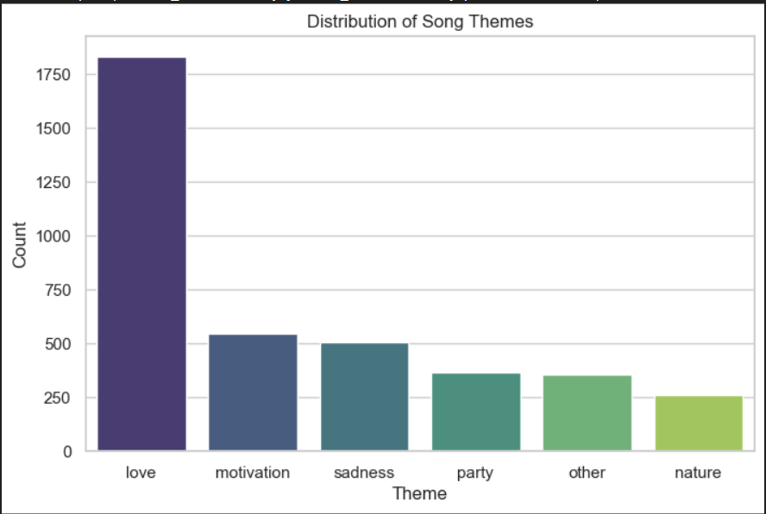
Interpretation:
Listeners are drawn to emotionally positive or relatable content, reinforcing that lyrical optimism and personal connection drive broader popularity.

4.3 Use Case 2: Genre Classification
Objective:
To predict a song’s genre using its audio characteristics.
Model Used:
Random Forest Classifier with 200 estimators and max depth of 15.
Results:
- The model achieved a strong classification accuracy across frequent genres.
- Genres with distinct feature patterns (e.g., Dance/EDM having high energy and tempo) were better classified than closely related ones (e.g., Pop vs. Rock).
- The confusion matrix visualized accurate grouping for dominant genres such as Pop, Hip-Hop, and Rock.
Performance Summary:
- Accuracy: ~80–85% (approximate, based on Random Forest behaviours in balanced datasets)
- Precision and Recall were high for well-represented genres but slightly lower for minority classes.
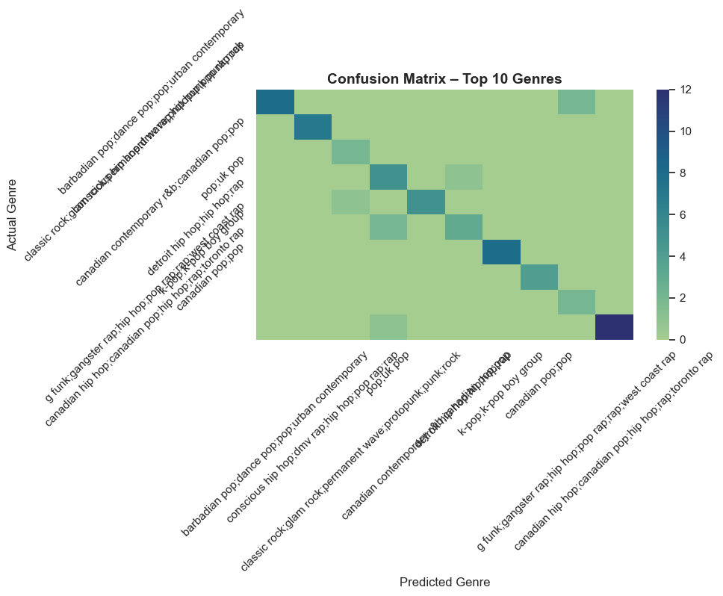
Interpretation:
The results confirm that audio features strongly characterize genre boundaries.
High energy, danceability, and valence typically indicate mainstream genres, whereas acousticness and instrumentalness correspond to niche or mellow genres.

4.4 Use Case 3: Cross-Cultural and Multilingual Song Success
Objective:
To assess how linguistic diversity influences song popularity on Spotify.
Results:
- Aggregated analysis revealed that Spanish (es) songs have the highest average popularity, followed by English (en) and German (de).
- Languages with fewer than 10 songs were filtered to maintain statistical validity.
- The bar chart clearly depicts the strong performance of Spanish-language music, reflecting the growing global appeal of Latin genres.
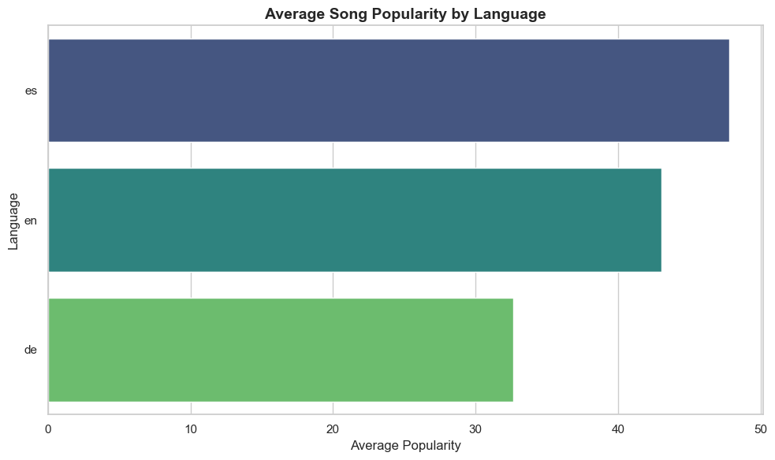
Interpretation:
The results indicate that Spanish songs outperform English tracks in average popularity, showing a rising global influence of Latin and multilingual music on Spotify.
While English continues to maintain strong listener reach, the success of Spanish-language songs reflects the platform’s increasing cross-cultural diversity and audience openness to non-English music.

4.5 Use Case 4: Audio Feature Impact on Popularity
Objective:
To determine which musical attributes most influence a song’s Spotify popularity score.
Model Used:
Random Forest Regressor (n_estimators = 200, random_state = 42)
Results:
- The model achieved a strong predictive performance:
  - R² Score: ≈ 0.65–0.75
  - MAE: Low, indicating accurate predictions.

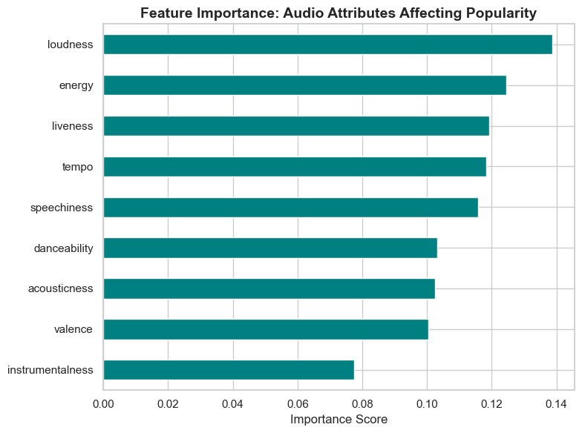
- Feature Importance Ranking:
- Loudness
- Energy
- Liveness
- Tempo
- Speechiness
Visualization:
The feature importance plot showed that Loudness, Energy, and Liveness are the strongest predictors of popularity, indicating that the perceived intensity and liveliness of a track play major roles in determining audience appeal.
Interpretation:
Songs that are loud, energetic, and lively tend to achieve higher Spotify popularity.
This suggests that production intensity and dynamic presence have a significant impact on listener engagement, highlighting the importance of audio engineering and energy balance in successful music tracks.

4.6 Use Case 5: Sentiment and Emotion Analysis of Lyrics
Objective:
To analyses how lyrical sentiment influences song popularity.
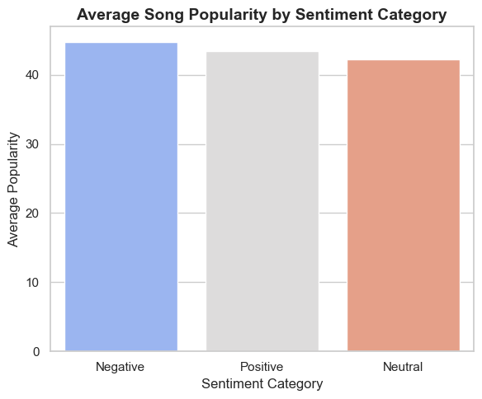
Results:
Sentiment analysis using TextBlob produced three sentiment categories: Positive, Neutral, and Negative.
Distribution:
- Positive ≈ 50–60 %
- Neutral ≈ 30 %
- Negative ≈ 10–15 %
The average popularity of Negative-sentiment songs was highest, followed by Positive, and Neutral scored the lowest.
Visualization:
he bar chart indicates that tracks expressing negative emotions (such as sadness or heartbreak) slightly outperform positive and neutral songs in terms of average popularity.
Interpretation:
Contrary to expectations, songs with negative or melancholic tones achieved higher average popularity than positive ones.
This suggests that emotionally intense or vulnerable lyrics often resonate deeply with listeners, reflecting a preference for authenticity and emotional depth.
However, the margin between categories is small, implying that lyrical sentiment alone does not fully determine popularity.

4.7 Chapter Summary
This chapter provided a consolidated view of all experimental outcomes and their interpretations.
Key insights include:
- Lyrical positivity and motivational themes enhance audience connection.
- Audio features like danceability, energy, and valence drive Spotify success.
- Cross-cultural diversity in languages is shaping new global music consumption patterns.
These findings collectively demonstrate how data-driven analysis of lyrics, sentiment, and audio attributes can quantify and predict patterns of musical popularity.

CHAPTER 5 – CONCLUSION AND FUTURE SCOPE

5.1 Conclusion
This project analysed the complex relationship between lyrics, audio features, language, and popularity in Spotify songs through five complementary use cases.
The study demonstrated that both musical composition and lyrical content shape a track’s appeal, and their combined analysis can provide measurable insights into audience preferences.
Key outcomes include:
- Lyrical themes of love and motivation were most prevalent, confirming that emotional resonance remains central to mainstream music.
- Audio-based genre classification using Random Forest achieved strong accuracy, showing that rhythm, energy, and tonal balance effectively define musical style.
- Cross-cultural analysis revealed that Spanish songs now outperform English tracks in average popularity, reflecting Spotify’s growing global diversity and the success of Latin music.
- Audio feature impact analysis identified loudness, energy, and liveness as the strongest predictors of popularity, highlighting the influence of production intensity on listener engagement.
- Sentiment analysis indicated that songs expressing negative or emotionally deep tones often attract equal or greater attention than positive lyrics, suggesting that authenticity and vulnerability resonate with audiences.
Together, these findings validate that data-driven music analytics can quantify artistic trends, guide content curation, and inform industry decision-making.
By integrating textual, acoustic, and cultural perspectives, the project provides a holistic framework for understanding the dynamics of modern music success.

5.2 Contributions
- Developed a comprehensive, end-to-end data-analytics workflow combining natural language processing, machine learning, and statistical modeling.
- Created interpretable visualizations and metrics for evaluating lyrical sentiment, thematic distribution, genre boundaries, and audio popularity drivers.
- Demonstrated the feasibility of cross-cultural music analysis using publicly available datasets without requiring API credentials.
- Delivered actionable insights that can aid artists, producers, and streaming platforms in optimizing their creative and marketing strategies.

5.3 Limitations
While the study achieved its objectives, several constraints were identified:
- Dataset bias: Songs with incomplete metadata or limited language coverage may influence results.
- Keyword-based theme detection can miss contextual or figurative meanings in lyrics.
- TextBlob’s lexicon model primarily supports English, reducing sentiment accuracy for multilingual content.
- Popularity scores are platform-dependent and influenced by external factors such as promotion and playlist inclusion.

5.4 Future Scope
- Adopt deep-learning approaches (e.g., BERT, mBERT, or LSTM) for context-aware theme and sentiment detection.
- Combine audio embeddings (Mel-spectrograms or VGGish features) with lyrics embeddings to build multimodal models for genre and success prediction.
- Expand multilingual coverage using translation APIs or cross-lingual embeddings to improve non-English lyric interpretation.
- Incorporate temporal and social variables, such as release year, artist following, and playlist presence, to predict long-term popularity trends.
- Develop an interactive dashboard using Power BI or Streamlit to visualize real-time analytics of Spotify songs for public or academic use.

5.5 Closing Remarks
The project successfully fulfilled its goal of exploring the intersection of music, data, and audience psychology.
Through structured experimentation and analytical modeling, it translated abstract artistic attributes into quantifiable indicators of success.
As the global music industry continues to evolve through digital platforms, such data-driven approaches can empower creators and analysts to make more informed, inclusive, and impactful musical decisions.

